The mid-1990s were crucial years for the future of the Kulaluk lease granted to Larrakia people in 1979. In 1994 a 99-year sub-lease and a 99-year under-lease were signed with developers that would alienate sections of Lot 5182 from Aboriginal use for generations. During this period, shocking Supreme Court transcripts reveal that the president of the Gwalwa Daraniki Association who signed the sub-leases was living in a demoralising domestic violence situation at Kulaluk with a non-Aboriginal drug-affected, racist, the father of her six children. As a spouse he was eligible to be a member of the land holding association and exerted such influence over the community that the GDA president was described as “his slave”. The following timeline suggests that developers and others took advantage of a vulnerable woman living under extreme duress and that therefore these agreements should not hold.

1984: Helen Secretary (15) in a defacto relationship with Darren Nelson (17) at Kulaluk.
From August 1991: Helen Secretary is President of Gwalwa Daraniki Association Inc (the Kulaluk leaseholders). According to Darwin Supreme Court transcripts, Helen testified that when she was President of the Kulaluk Community Nelson would “come to the [Kulaluk] office and advise me about things”. Helen further stated, if she disagreed with Nelson, “when I went home I used to get a flogging … We were his property”.
August 22, 1993: Northern Territory News reports that a “huge commercial, tourism and leisure park is planned for Darwin. The site earmarked is at Kulaluk, vacant Aboriginal land bounded by Bagot Road and Dick Ward Drive … the international food chain McDonalds has agreed to become a tenant and negotiations were being held with several other enterprises. The proposal – developed by architects Woods Bagot for Mr Smith’s Darwin-based family company Vysrose Pty Ltd [later Citiland] – is now with the Town Planning Authority. It was lodged following the signing of an option for a long-term lease with the owner of the land, the Gwalwa Daraniki Association.”
July 8, 1994: Register Book of Crown Leases (Volume 200, Folio 13) from Gwalwa Daranki Association Inc. (Lessor) to Vysrose Pty Ltd (Lessee) for a term of 99 years (8 July 1994 to 7 July 2094) for an annual rent of $10,000.00 (made in four quarterly payments of $2,500.00).
July 8, 1994: Vysrose Pty Ltd and Gwalwa Daraniki Association Inc. (Under Lessors) grant an Under-lease (under Sublease No. 34591) to McDonalds Properties (Australia) Pty Ltd (Under Lessor) in Lot 5182 Town of Darwin from plan(s) S 77/093B from 8 July 1994 to 6 July 2094 for a lump sum of $240,000.00 for the first ten years and an annual rent of $20,000 thereafter.
October 21, 1994: Helen Secretary attempts to bring a restraining order against Nelson.
November 20, 1994: Helen Secretary shoots Nelson while he is asleep in their house at Kulaluk.
November 27, 1995: Trial of Helen Patricia Secretary commences and continues to 4 December. John Lawrence for the defence states: “...the deceased, who was a wife basher, had graduated from alcohol and marijuana to chemical drugs. He was injecting [himself with] chemical drugs, drugs purchased for him by his wife, his slave, the accused.” Nelson was also described as a “racist” who hated Blacks.
December 2, 1995: Psychiatrist Dr Joan Lawrence tells the court the pattern for battered women was to become almost totally controlled by their partner. “It affects the way you perceive things; it affects the way you apprehend things; it affects the way you judge things. In a sense you're basically beaten into a different perspective.”
September 6, 1996: An appeal quashes Secretary’s conviction for manslaughter and orders a new trial.
August 1997: “Kulaluk Development Proposal - Development Brief for the Development of Part Lot 5182, Bagot Rd Town of Darwin” prepared by the Gwalwa Daraniki Association Inc and Vysrose P/L.
May 19, 1998: Bob Watt in NT News reports (page 1): “A woman who shot her sleeping husband in the back walked free from the Supreme Court yesterday after her second trial over the killing. A jury found Helen Patricia Secretary not guilty of the manslaughter of her husband.
May 22, 1998: Kulaluk native title application to National Native Title Tribunal, “Prince of Wales, Helen Secretary and Bill Risk on behalf of the Larrakia People” (the applicants).

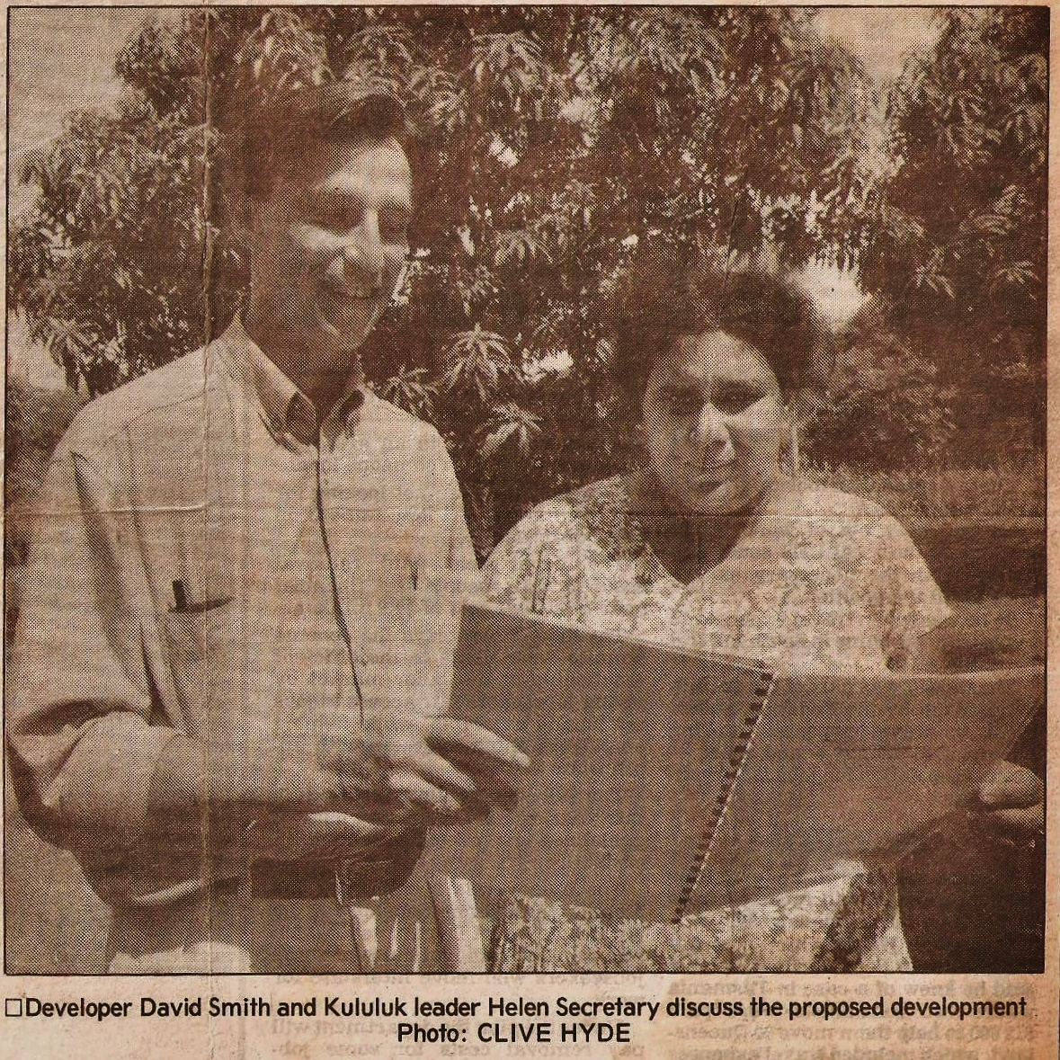
Photo below from NT News, August 22, 1993

